The title screen is going to be a depiction of the tower the princess is trapped in from the outside, in the middle of the forest. It should give feelings of loneliness, and being trapped.

It should use a perspective from way below the tower looking up, to make the tower seem tall, isolated, impossibly high and unreachable.

A small window at the side of the top of the tower is lit orange by the princess’ candle in her room

Around the bottom/side edges of the screen are the forest trees reaching into the night sky

Filling the rest of the space is the night sky, filled with specs of stars, and a full moon

**NOTE:** the middle of the screen will have the game title and play button, so place the princess’ candle-lit window high ABOVE the center of the screen so it is visible

Perspective reference:

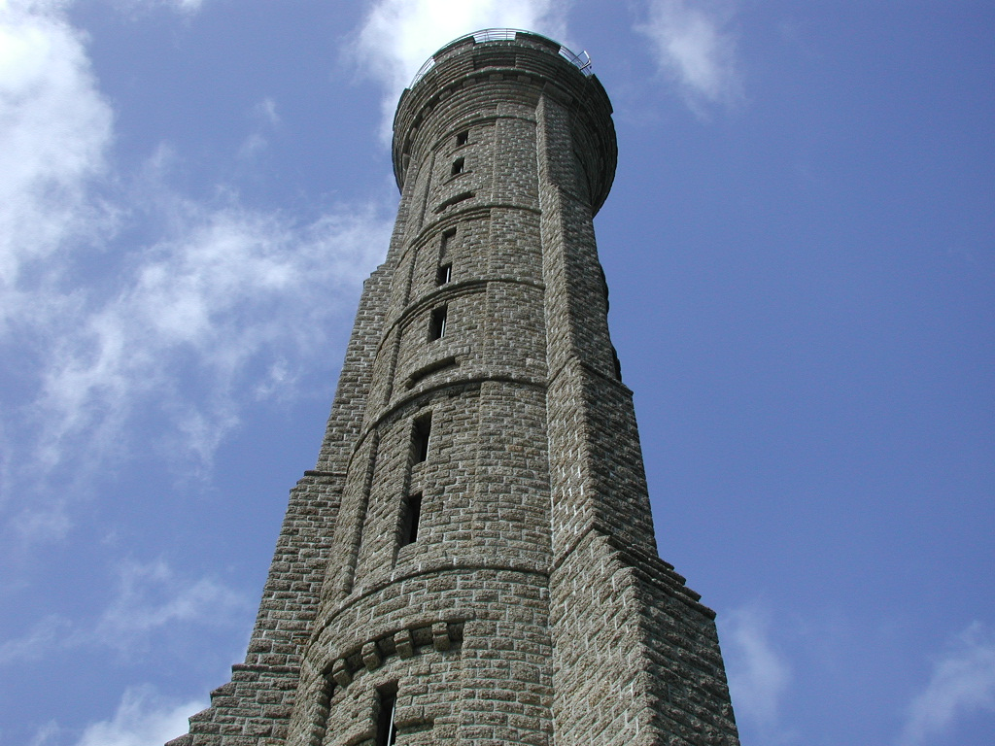

Tower style reference:

